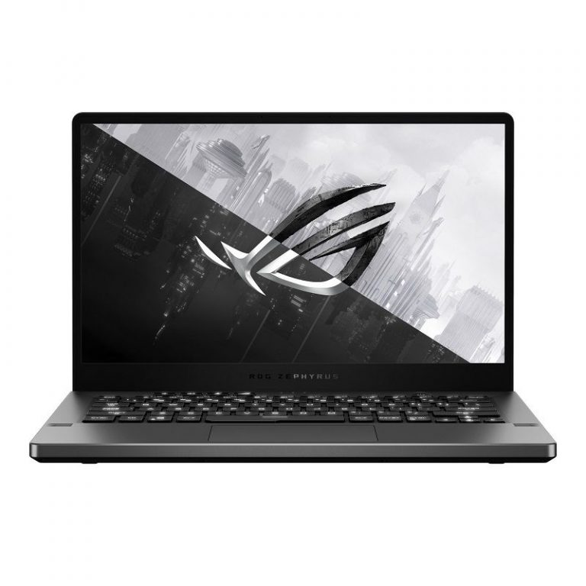

**ASUS ROG ZEPHYRUS G14**

**Giá: 39.990.000₫**

|  |  |
| --- | --- |
| **CPU** | [*AMD Ryzen 7 – 4800HS*](https://xgear.vn/cpu/amd-ryzen-7-4800hs/) |
| **Hệ điều hành** | [*Windows 10 SL 64 Bit*](https://xgear.vn/he-dieu-hanh/windows-10-sl-64-bit/) |
| **RAM** | [*DDR4 16GB (8GB Onboard, 1 slot 8GB 3200MHz)*](https://xgear.vn/ram/ddr4-16gb-8gb-onboard-1-slot-8gb-3200mhz/) |
| **GPU** | [*Geforce GTX 1660Ti*](https://xgear.vn/gpu/geforce-gtx-1660ti/) |
| **Màn hình** | [*14" 2K (2560 x 1440) IPS, 100% sRGB*](https://xgear.vn/man-hinh/14-2k-2560-x-1440-ips-100-srgb/) |
| **Ổ cứng SSD** | [*512GB SSD NVMe M.2 PCIe Gen 3 x 4*](https://xgear.vn/o-cung-ssd/512gb-ssd-nvme-m-2-pcie-gen-3-x-4/) |
| **Wireless Lan** | [*Intel Wi-Fi 6 AX201(2*2 ax) + BT5*](https://xgear.vn/wireless-lan/intel-wi-fi-6-ax20122-ax-bt5/) |
| **Các cổng kết nối** | [*1 x HDMI 2.0*](https://xgear.vn/cac-cong-ket-noi/1-x-hdmi-2-0/)*,*[*1 x Type C USB3.1 (GEN2) support DP function*](https://xgear.vn/cac-cong-ket-noi/1-x-type-c-usb3-1-gen2-support-dp-function/)*,*[*2 x Type-A USB 3.1 (Gen 1)*](https://xgear.vn/cac-cong-ket-noi/2-x-type-a-usb-3-1-gen-1/) |
| **Bàn phím** | * *Backlight Keyboard* |
| **Kích thước** | [*(WxDxH) 32.4 x 22.0 x 1.99 cm*](https://xgear.vn/kich-thuoc/wxdxh-32-4-x-22-0-x-1-99-cm/)*,*[*360 (W) x 252 (D) x 18.9 (H) mm*](https://xgear.vn/kich-thuoc/360-w-x-252-d-x-18-9-h-mm/) |
| **Trọng lượng** | [*1.7kg*](https://xgear.vn/trong-luong/1-7kg/) |